Assignment-15.5: Build and Deploy Hadoop word count program using SBT.

Creating the project:

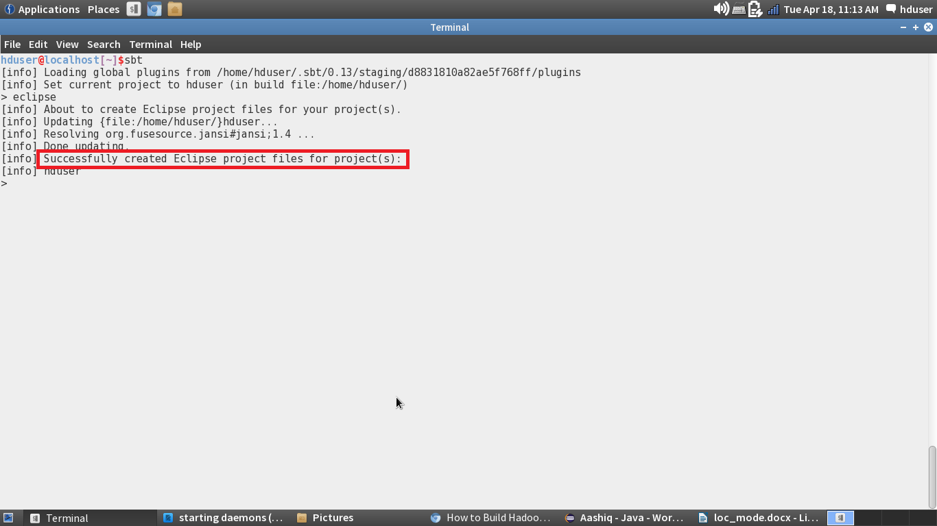

I am creating a folder named **Hadoop_app_sbt**and inside **src/main/java.**I have pasted the code of Hadoop word count program. The tree diagram is shown below

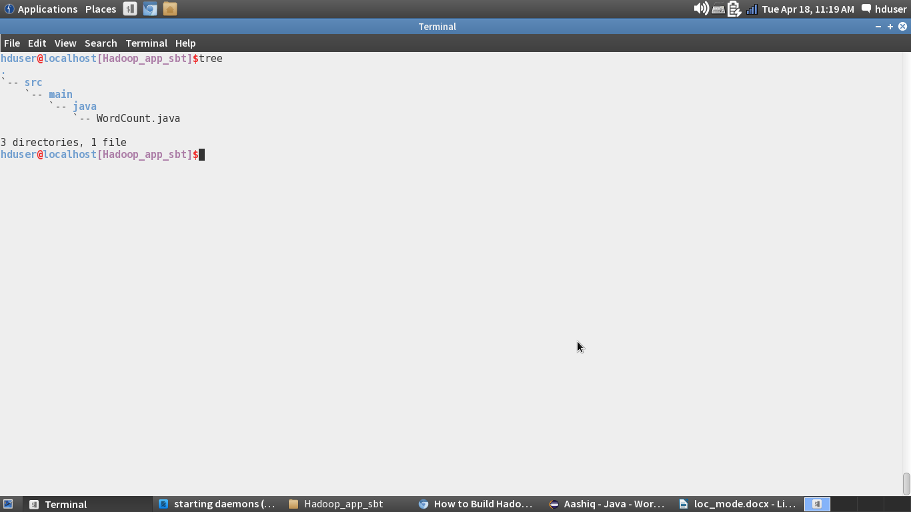

Compiling the code and Building the Project:

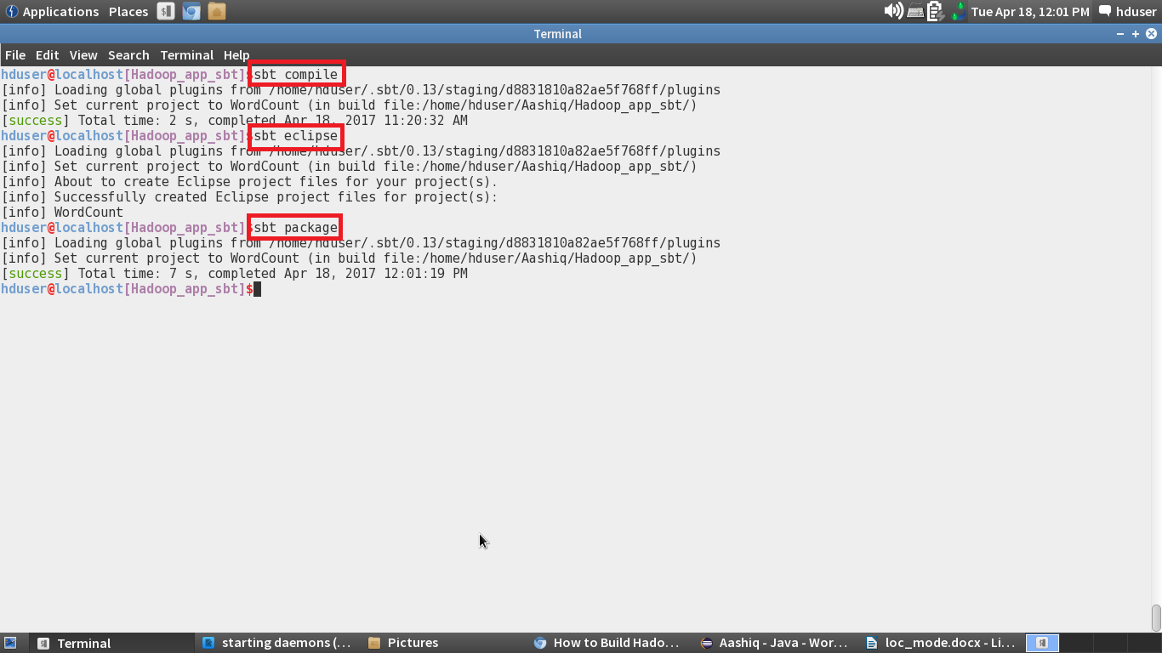

Importing the Project into the Eclipse:

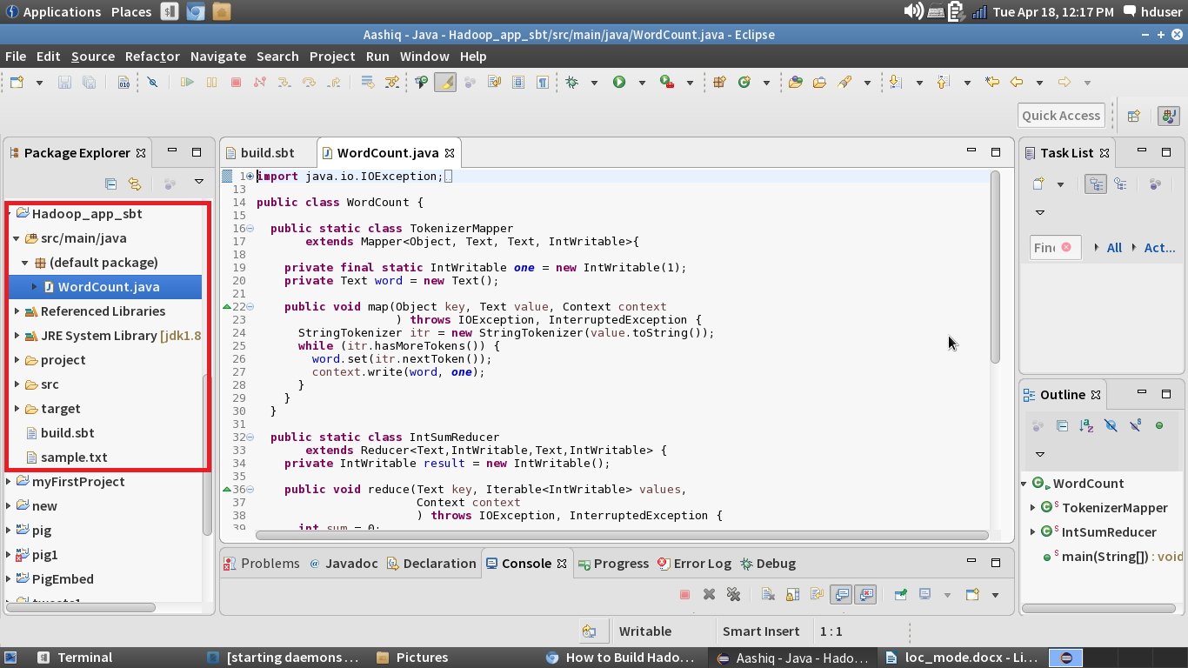

Jar Created-Tree Diagram:

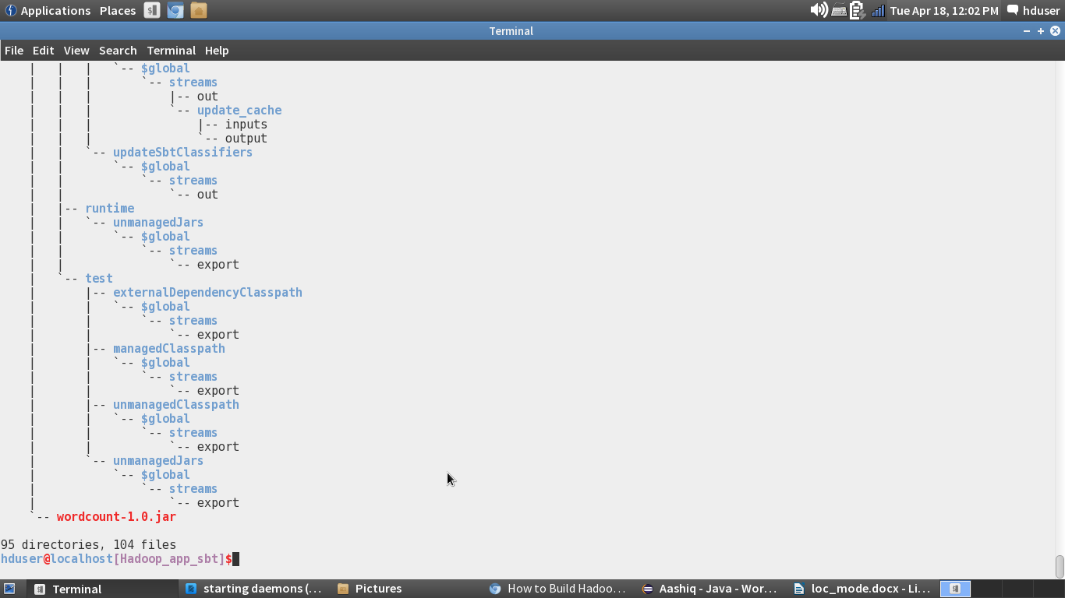

Running the Jar File:

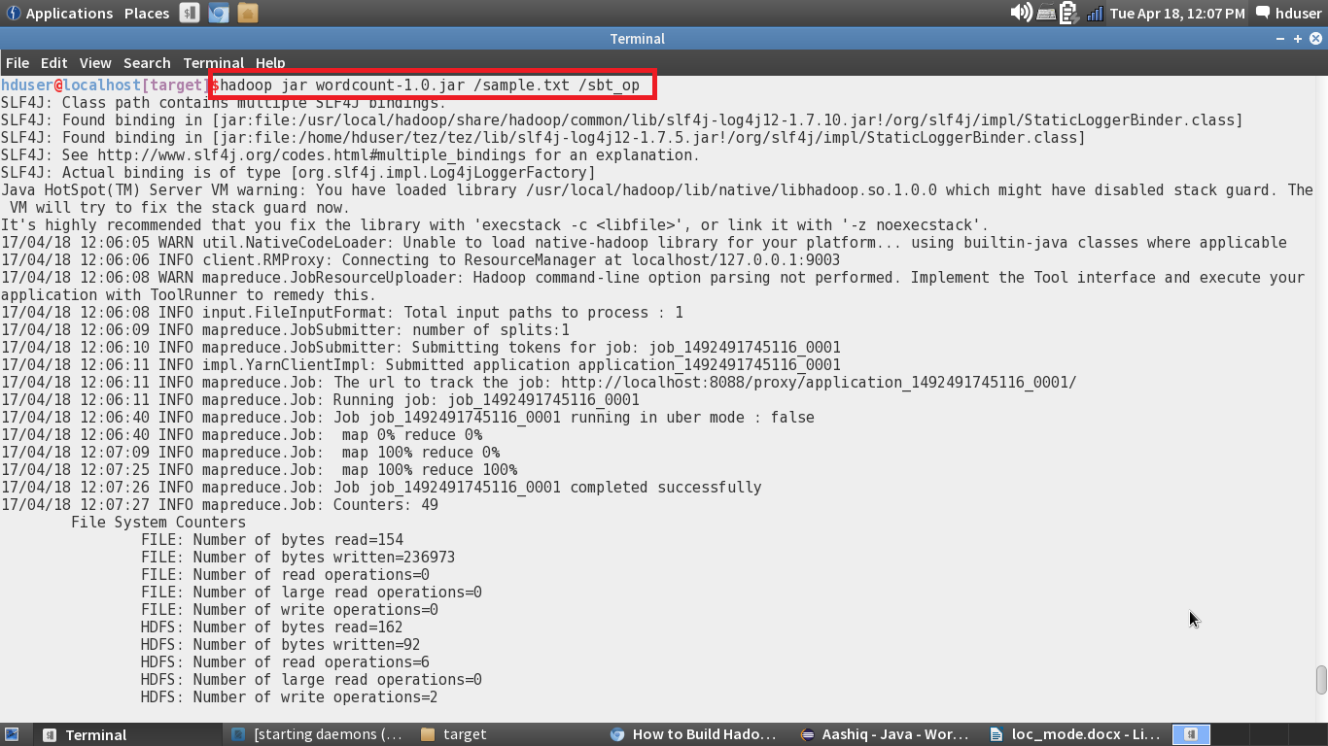

Output of the WordCount Program:

